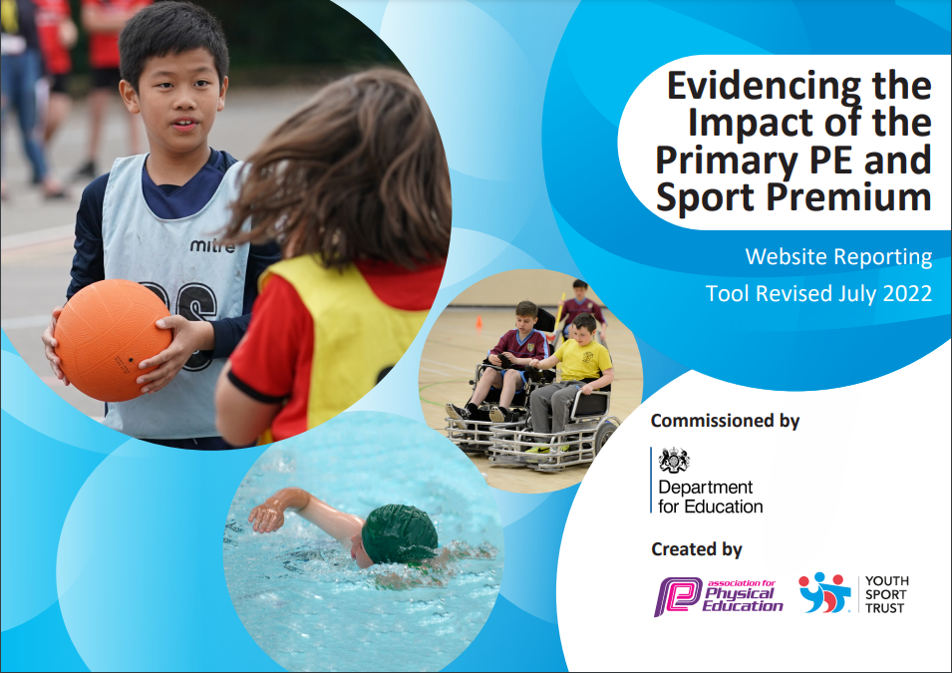
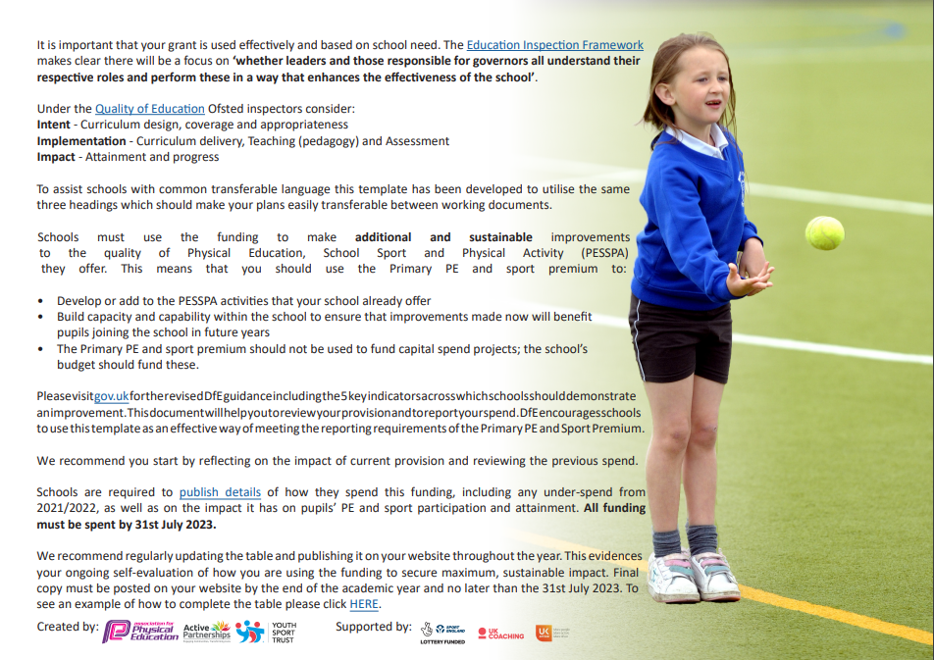
Village Primary Academy
Academic Year 2022-23
Rationale

At Village Primary Academy we aim to build on children’s natural enthusiasm for physical exploration by providing stimulating, purposeful and challenging experiences through games, dance, gymnastics, swimming, athletics and outdoor and adventurous activities. We aim for as many pupils as possible to engage in activities that promote their physical development including being involved in competitive sports.
We know from evidence that physically active children are not only healthier but do better academically and in life; they are far more likely to be active as adults. The first ten years of life provide children with a blueprint for their adult lives and is the time when they develop the critical fundamental movement skills that act as foundations and building blocks for future activity.

Summary of Proposed activity for 2022-23
- Ensure the whole school (including EYFS) is well equipped to deliver high quality PE for the new curriculum.
- Staff CPD within PE lessons.
- The inclusion of all pupils in PE inside and outside of school.
- Improving the activity levels before, during and after school.
- Children are provided with the opportunity to participate in a wide range of sports and sporting events (Both competitive and for pleasure).
Intended Impact of the Pupil Premium / Sports Funding

It is intended that the above actions will be sustainable over time as they focus on:

- the engagement of all pupils in regular physical activity

- raising the profile of PE and sport across the school as a tool for whole-school improvement

- increased confidence, knowledge and skills of all staff in teaching PE and sport

- broader experience of a range of sports and activities offered to all pupils

- increased participation in competitive sport

Review of our previous strategy

Key achievements to date: | Areas for further improvement and baseline evidence of need:
- Achieved the Bronze School Games Mark in 2022  - A return to an inclusive and competitive Sports Day following COVID  - All children provided with the opportunity to attend an after school club (free of charge) or an out of school competition  - Increase of outside agency relationships to provide greater sporting opportunities  - An increase in physical activity levels before, during and after school  - Structured sport provided at lunch times  - A well-equipped PE curriculum | - The assessment of pupils in PE  - The knowledge of SEND adaptations in some staff  - To provide more competition for pupils  - To improve the fitness levels of pupils identified as overweight  - To improve the physical literacy across the school

Academy Swimming Data

Meeting national curriculum requirements for swimming and water safety | Please complete all of the below*:
What percentage of your current Year 6 cohort swim competently, confidently and proficiently over a distance of at least 25 metres? | 23%
What percentage of your current Year 6 cohort use a range of strokes effectively [for example, front crawl, backstroke and breaststroke]? | 22%
What percentage of your current Year 6 cohort perform safe self-rescue in different water-based situations? | 15%
Schools can choose to use the Primary PE and Sport Premium to provide additional provision for swimming but this must be for activity over and above the national curriculum requirements. Have you used it in this way? | No

Action Plan and Budget Tracking
Capture your intended annual spend against the 5 key indicators. Clarify the success criteria and evidence of impact that you intend to measure to evaluate for students today and for the future.

Academic Year: 2022/2023 | Total fund allocated: £24,210 (The school subsidised £3,000 of this to support the funding of “active breakfast” sports club) | Date Updated: 08.06.23
Key indicator 1: The engagement of all pupils in regular physical activity – Chief Medical Officer guidelines recommend that primary school children undertake at least 30 minutes of physical activity a day in school |  |  |  | Percentage of total allocation:
 |  |  |  | 27%
School focus with clarity on intended impact on pupils: | Actions to achieve: | Funding allocated: £8,730  (School subsidised £3,000 of this to fund “active breakfast” sports club from AU1-SPR1) | Evidence and impact: | Sustainability and suggested next steps:
Increase in physical activity levels across the school. | - The introduction of “physically active” breakfast clubs  - The introduction of “physically active” lunchtimes.  - All children to be offered a place on at least one after school club (funded).  - Build relationships with outside agencies that offer opportunities for physical activity.  - Children to be provided with opportunities to participate in sporting events both in and out of school. | £8,730  (School subsidised £3,000 of this to fund breakfast clubs from AU1-SPR1) | - Breakfast club with Premier Sport ran from Sep-Jan. These children were provided with a daily 40 minute sport session.  - Daily lunch clubs provided by DCCT and Premier Sport. Engagement is high and children are exposed to range of physical activity.  - All children offered a funded place on a sport after school club.  - Over 60% of Year 1-6 have taken part in at least one club.  - Children are provided with 2x PE lessons per week – one is delivered by an outside agency  - Fitness assessments (Year 1&2) – 100% of pupils improved their fitness when comparing September and April.  - Physical literacy (Year 2) – 100% of pupils improved after an 8 week Physical Literacy Intervention.  - All Year groups competed in at least 1 sporting event outside of school.  - Targeted lunch club 1x per week for those identified as above weight for their age.  - In targeted lunch club, 100% improved in their fitness and 100% said their enjoyment in physical had improved. | - Approach to clubs is sustainable with the renewal of the sport premium.  - Target children that did not attend a club this year for 23/24  - Pupil voice on clubs to maintain high attendance
Children provided with sporting opportunities both inside and outside of normal school hours to develop a love of sport and active lifestyles. | - The introduction of “physically active” breakfast clubs  - The introduction of “physically active” lunchtimes.  - All children to be offered a place on at least one after school club (funded).  - Build relationships with outside agencies that offer opportunities for physical activity.  - Children to be provided with opportunities to participate in sporting events both in and out of school.  - Provide a wide and well-balanced PE curriculum. |  | - Children are now provided with daily sporting opportunities with our active lunch clubs by Premier Sport – engagement in the sessions is high.  - All children offered a funded place on a sport after school club.  - Over 60% of Year 1-6 have taken part in at least one club.  - Membership purchased with DCCT.  - School attended over 10 sporting events with DCCT (mixture of year groups).  - In school opportunities provided by Derby Cricket Club, Premier Sport and DCCT. | - Approach to continue next year with renewal of sport premium.  - Target children who lacked participation this year.  - Conduct a pupil voice to ensure participation remains high.
Children exposed to high-quality PE twice a week to develop skills needed to succeed in sport. | - The use of outside agencies to deliver one PE lesson per week.  - Build relationships with outside agencies that can offer new PE opportunities.  - Provide a structured and well thought out PE curriculum. |  | - PE delivered once a week by DCCT and Premier Sport.  - Teachers undertake CPD whilst outside agency lessons occur.  - SPR1 – Year 2 undertook a 6-week cricket scheme with Derby Cricket Club. | - Renew membership with DCCT to continue next year.  - Discuss with teachers any new CPD they require.
Key indicator 2: The profile of PE and sport being raised across the school as a tool for whole school improvement |  |  |  | Percentage of total allocation:
 |  |  |  | 19%
School focus with clarity on intended impact on pupils: | Actions to achieve: | Funding allocated: £4,000 | Evidence and impact: | Sustainability and suggested next steps:
The increase of participation in sporting events both inside and outside of school to develop a love of sport and physical activity. | - All children to be offered a place on at least one after school club (funded).  - Build relationships with outside agencies that offer opportunities for physical activity.  - Children to be provided with opportunities to participate in sporting events both in and out of school.  - Delivery of an inclusive and competitive sports day | £4,000 | - All children in the school offered the opportunity to attend at least 1 funded after school club.  - Over 60% of children participated in at least 1 funded after school club.  - School delivered an inclusive Sports Day in June 23.  - All year groups attended at least 1 out of school sporting activity (Multi-skills, Dodgeball, Cricket, Football, Athletics, Swimming, Ultimate Frisbee, Golf, Quidditch) | - Identify children who lacked participation this year for 23/24  - Renewal of approach for 23/24 with the renewal of the Sport Premium
Children to lead active and healthier lifestyles in school and beyond. | - The introduction of “physically active” breakfast clubs  - The introduction of “physically active” lunchtimes.  - All children to be offered a place on at least one after school club (funded).  - Build relationships with outside agencies that offer opportunities for physical activity.  - Children to be provided with opportunities to participate in sporting events both in and out of school.  - To deliver learning schemes that give children the knowledge of healthier and active lifestyles  - To provide opportunities around the love of physical activity rather than competition |  | - All children provided with the opportunity of an active lunch club to develop their love of sport.  - Children identified as overweight or lacking a love of sport invited to a targeted lunch club with DCCT  - From invitations, 85% took up the offer.  - From the 85%, fitness and enjoyment of improved in 100% of pupils.  - In Year 2, those with low Physical Literacy undertook a 6 week intervention – 100% of these children improved.  - Year 5 undertook the Joy of Movement scheme in AU2. Children provided with knowledge and understanding of a active and healthy lifestyle.  - FS undertook Rammie’s Little Movers to promote an active and healthy lifestyle from a young age  - The whole school hosted and took part in a Joy of Movement festival with DCCT – aimed at promoting and showcasing healthy and active lifestyles. | - Renewal of sport clubs following the renewal of the sport premium  - Continue to monitor those in targeted lunch clubs to prevent regression  - Joy of movement message to be continuously promoted around the school  - Physical literacy to be promoted to parents to complete outside of school

Key indicator 3: Increased confidence, knowledge and skills of all staff in teaching PE and sport |  |  |  | Percentage of total allocation:
 |  |  |  | 37%
School focus with clarity on intended  impact on pupils: | Actions to achieve: | Funding  allocated:£7,880 | Evidence and impact: | Sustainability and suggested  next steps:
An improvement in staff knowledge when teaching PE to deliver high-quality lessons to pupils. | - An outside agency to deliver 1 PE lesson per week.  - Discussions with staff on the need of CPD in the school.  - Build relationships with outside agencies that offer opportunities for new CPD | £7,880 | - 100% of staff found the outside agency PE useful.  - Staff subject knowledge has improved in most areas  - Upon observations, lessons are inclusive of all pupils.  - More able pupils have been identified for out of school sporting events. | - Staff survey on desired CPD.  - Lesson observations to monitor the subject.  - Improve the assessment of PE in the school.
PE lessons are appropriately resourced to ensure all lesson are inclusive of SEND pupils. | - Discussions with class teacher and SENDCO on needed equipment  - To follow guidance from child’s IEP’s and EHCPs  - A yearly stock take on equipment and standard of equipment |  | - Identified pupils have a bag of resources to allow them to participate in PE where it is usually difficult for them  - EHCP targets are being met through schemes like Physical Literacy  - School is stocked to ensure all pupils participate in PE lessons and Sports Day. | - Continue to have discussions with SENDCO  - New pupils to be highlighted to ensure appropriate equipment is purchased  - Yearly checks of equipment and condition
Staff are aware on how to adapt lessons to support less able pupils and challenge higher ability. | - Discussions with staff on the need of CPD in the school.  - Build relationships with outside agencies that offer opportunities for new CPD  - Work with school SENDCO on supporting teachers with SEND pupils |  | - Identified pupils have a bag of resources to allow them to participate in PE where it is usually difficult for them  - More able pupils have been identified for out of school sporting events.  - PE lead by an agency 1x per week to provide staff with ideas | - Continue approach in 23/24  - Ensure new staff members receive the same support and training
Key indicator 4: Broader experience of a range of sports and activities offered to all pupils |  |  |  | Percentage of total allocation:
 |  |  |  | 9%
School focus with clarity on intended  impact on pupils: | Actions to achieve: | Funding  allocated: £2,000 | Evidence and impact: | Sustainability and suggested  next steps:
To provide a well-balanced and broad curriculum to ensure children are exposed to a range of sporting activities. | - Review and adapt current curriculum from 21/22  - Ensure that curriculum meets the needs of the National Curriculum  - Use an outside agency to deliver 1x PE lesson per week  - Build relationships with outside agencies that can deliver new parts to our curriculum | £2,000 | - School curriculum adapted following feedback from staff in 21/22 – a focus on multi skills for longer; more pupil choice and longer spent on gymnastics.  - Curriculum is progressive and covers all NC content.  - Outside agency delivering new/unique sports – for example Ultimate Frisbee in Year 4  - Children identified as below expectations are provided with intervention such as Physical Literacy and Rammie’s Healthy Heroes. | - Seek more new and unique sports for 23/24
A range of equipment to ensure children can partake in a range of physical activity. | - Discussions with class teacher and SENDCO on needed equipment  - To follow guidance from child’s IEP’s and EHCPs  - A yearly stock take on equipment and standard of equipment |  | - Purchasing of new equipment to deliver sports such as Tennis, Gymnastics and Tag Rugby.  - Identified pupils have a bag of resources to allow them to participate in PE where it is usually difficult for them | - Continue to check and monitor equipment  - Continue discussions with SENDCO to meet the needs of all pupils.
Key indicator 5: Increased participation in competitive sport |  |  |  | Percentage of total allocation:
 |  |  |  | 8%
School focus with clarity on intended  impact on pupils: | Actions to achieve: | Funding  allocated: £1,600 | Evidence and impact: | Sustainability and suggested  next steps:
All children are provided with opportunities to participate in competitive sport – both in and out of school. | - Provide opportunities and transport to compete in competitive sport outside of school  - Purchase resources to deliver competitive events in school  - Ensure all PE lessons have a competitive aspect to them  - Align after school clubs with upcoming competitions to provide chances to train | £1,600 | - 100% of children offered the opportunity to participate in a funded after school club.  - Over 60% of children participated in at least 1 after school club.  - Whole school took part in over 10 out of school events with DCCT  - Year 2 undertook a 6 week coaching scheme with Derby Cricket Club  - After school clubs delivered 4x per week that matched upcoming sporting events  - School Football team competed in 12 fixtures over the year in a league and cup  - Purchased school planning ends all lessons with a competitive game  - All year groups had at least 1x PE lesson per week delivered by an outside agency in at least 1 full term | - Identify staff to run more competitive school teams after school  - Identify pupils who lacked participation for 23/24
Children to be trained and taught the needed skills to succeed in competitive sport. | - Align after school clubs with upcoming competitions to provide chances to train  - The introduction of “physically active” lunchtimes to practise sport  - An increase of staff knowledge to develop the skills of pupils |  | - After school clubs delivered 4x per week that matched upcoming sporting events  - All year groups had at least 1x PE lesson per week delivered by an outside agency in at least 1 full term  - Year 2 undertook a 6 week coaching scheme with Derby Cricket Club  - School Football team competed in 12 fixtures over the year in a league and cup | - SU2 Clubs are for targeted children for 23/24 events  - Use SU2 PE assessments from outside agencies to support with team making for 23/24 events

Approval route:
Sports Premium Lead: Ryan Bailey | Date: 08.06.23
Principal: | Date:
Trust Leader: | Date:

